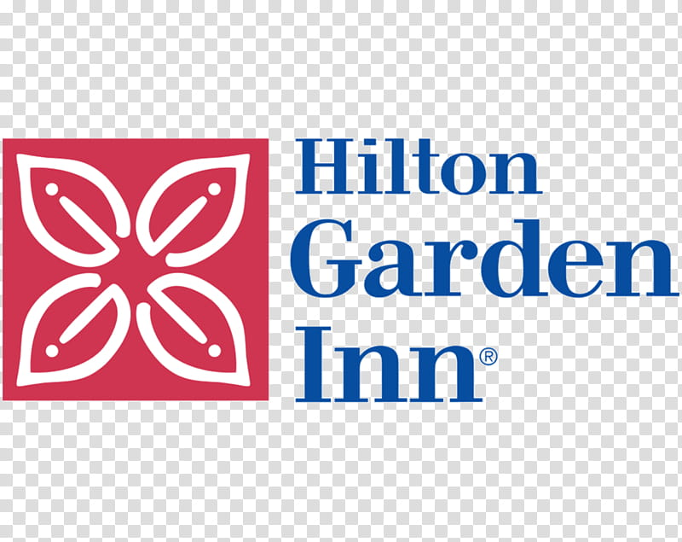

Right click below to open hyperlink to book your room

$145
HOMECOMING

